**Project**

**1- DC1 :**

**Domain Controller (ITI.edu)**

**DHCP 10.10.10.**

**IIS (HTTP) (www.sysweb.com)**

**add the Webpage to DNS**

**2- DC2 :**

**RODC**

**only HELP_USER can access DC2**

**3- PC1 :**

**Join ITI.edu Domain**

**Get IP 10.10.10.100 from DHCP on DC1 (Reservation)**

**4- User1 : Can't use flash memory**

**5- User2 : when login he found that WinRAR.msi (not exe) is installed**

**6- User3 : access the webpage and then take screenshot of nslookup command**

**7- User4 : can access DC1 (Remote Desktop) from PC1**

**8- Create a new vm (PC2) without iso file and make DC1 Install the windows 10 iso on PC2 automatically Using WDS (Windows Deployment Services)**

**9- Create 20 User account automatically using Powershell Script**

**On dc1**

1-add active directory & DNS services

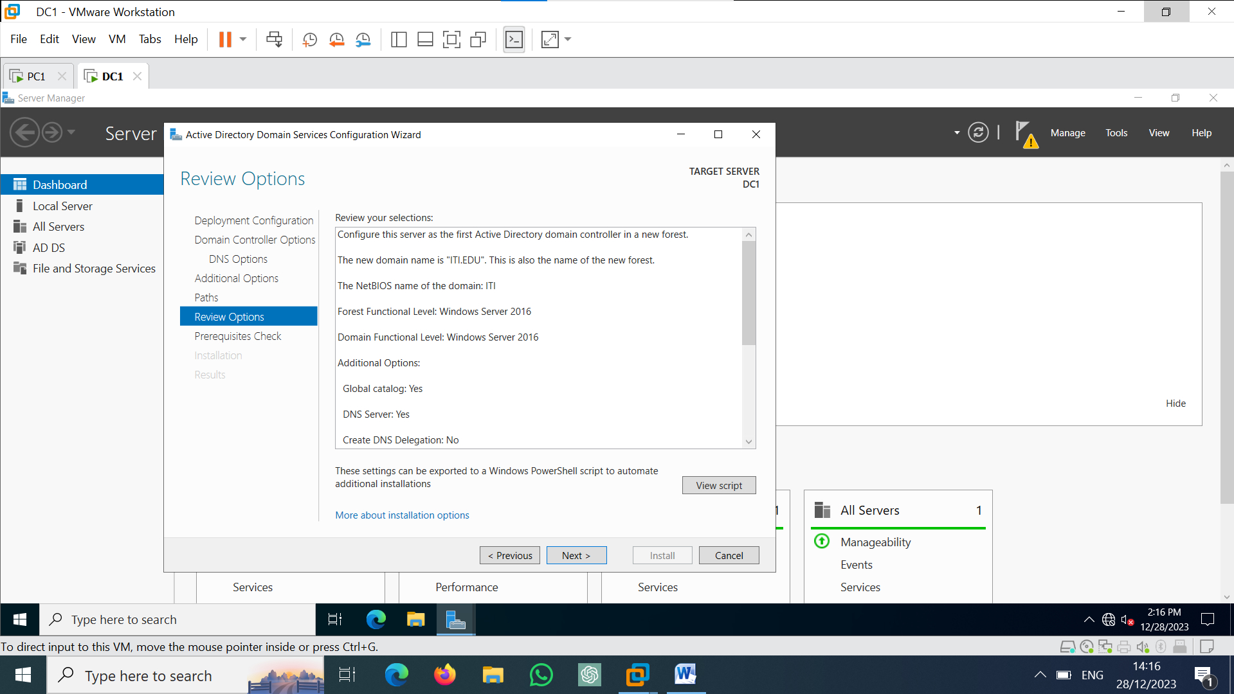

2-add IIS service

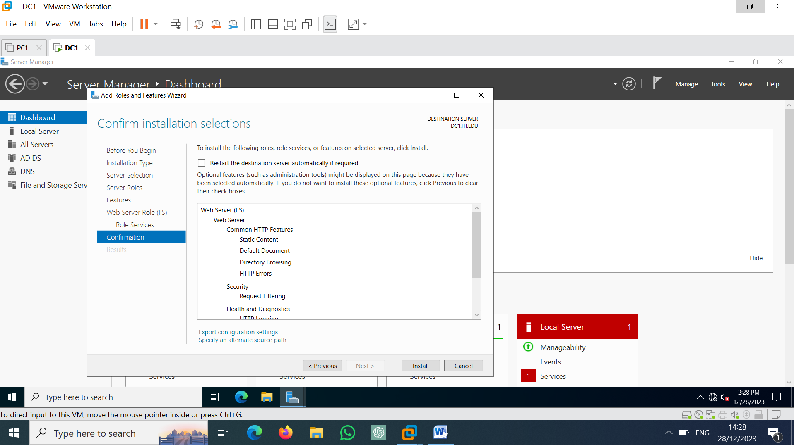

3-add DHCP service

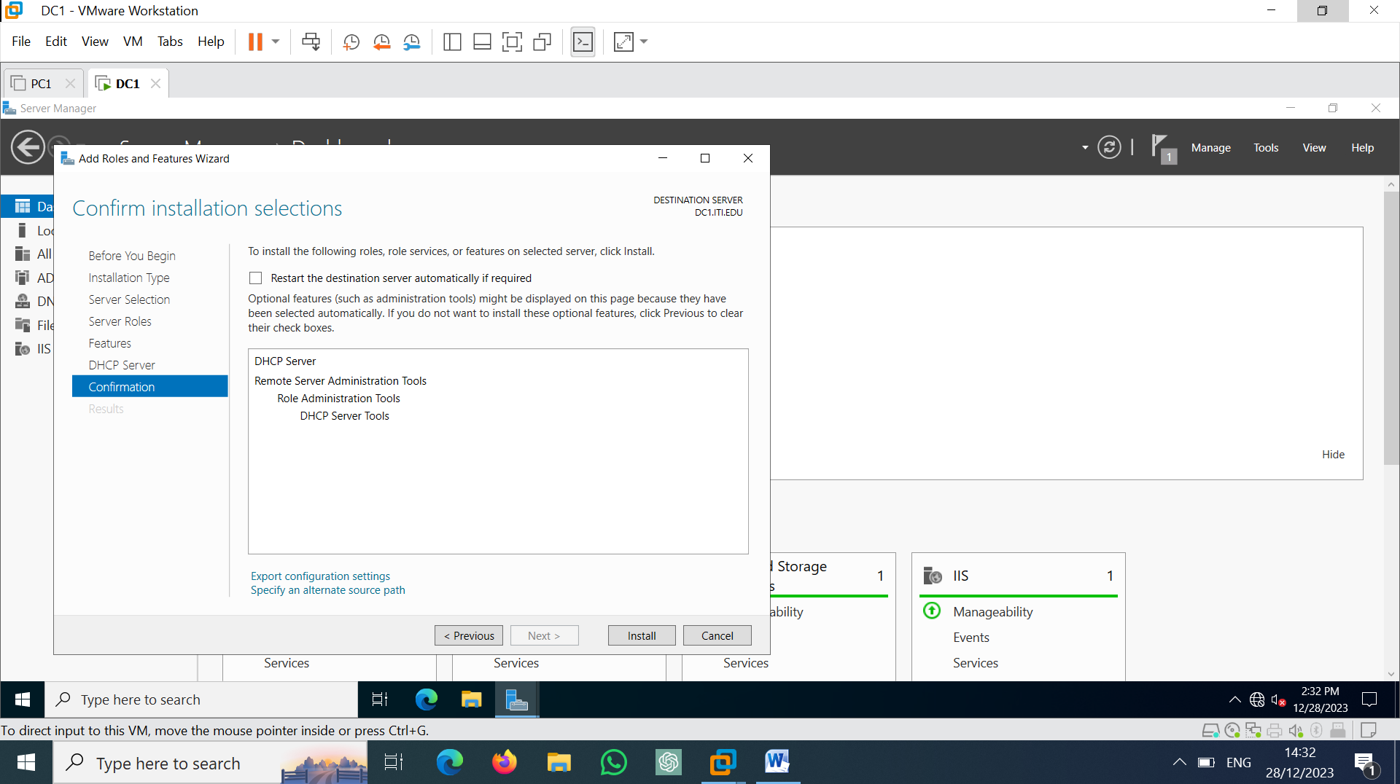

On dc1

-tools >> active directory users and computers >> add new OU ‘INFRA’ and add OU users in it

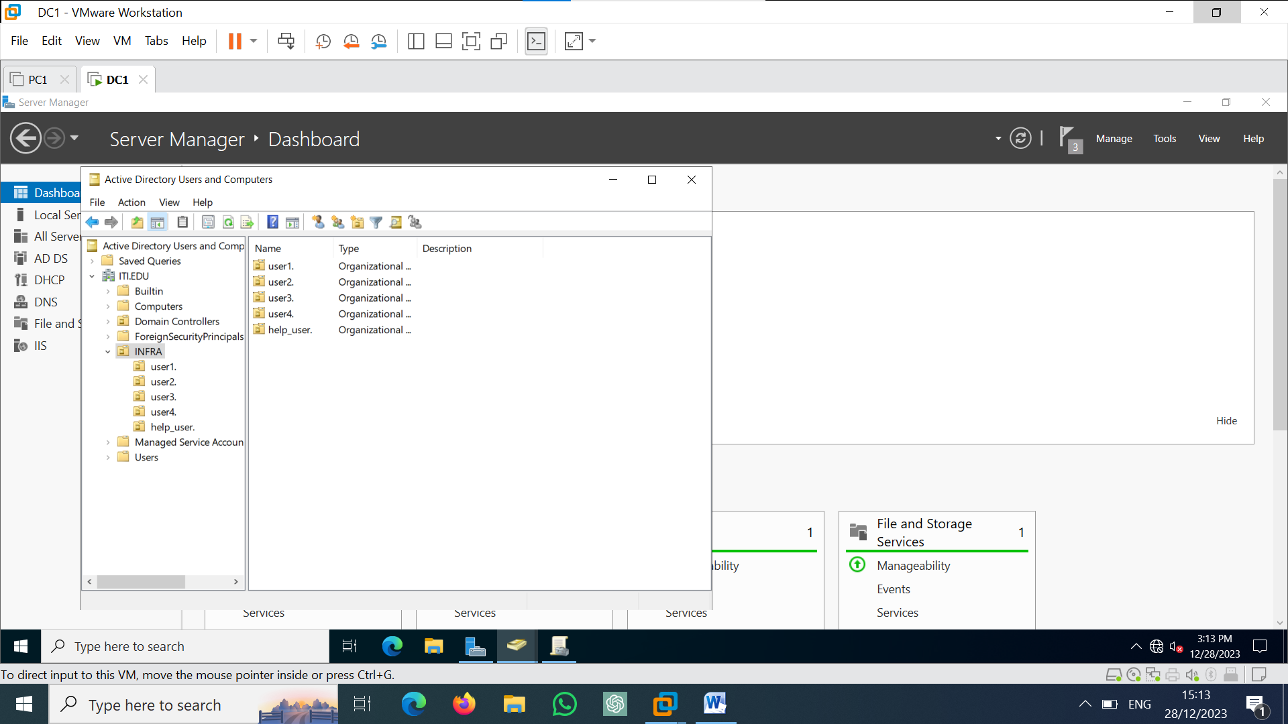

1-block flash memory to user1

Add “block flash memory” policy and edit it

User configuration >> Administrative templates >> system >> removable storage access.

And then go to “all removable storage classes : deny all access “ and enable it

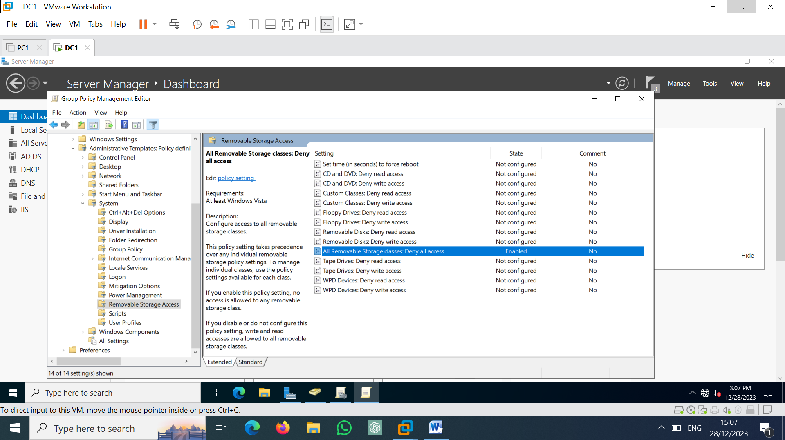

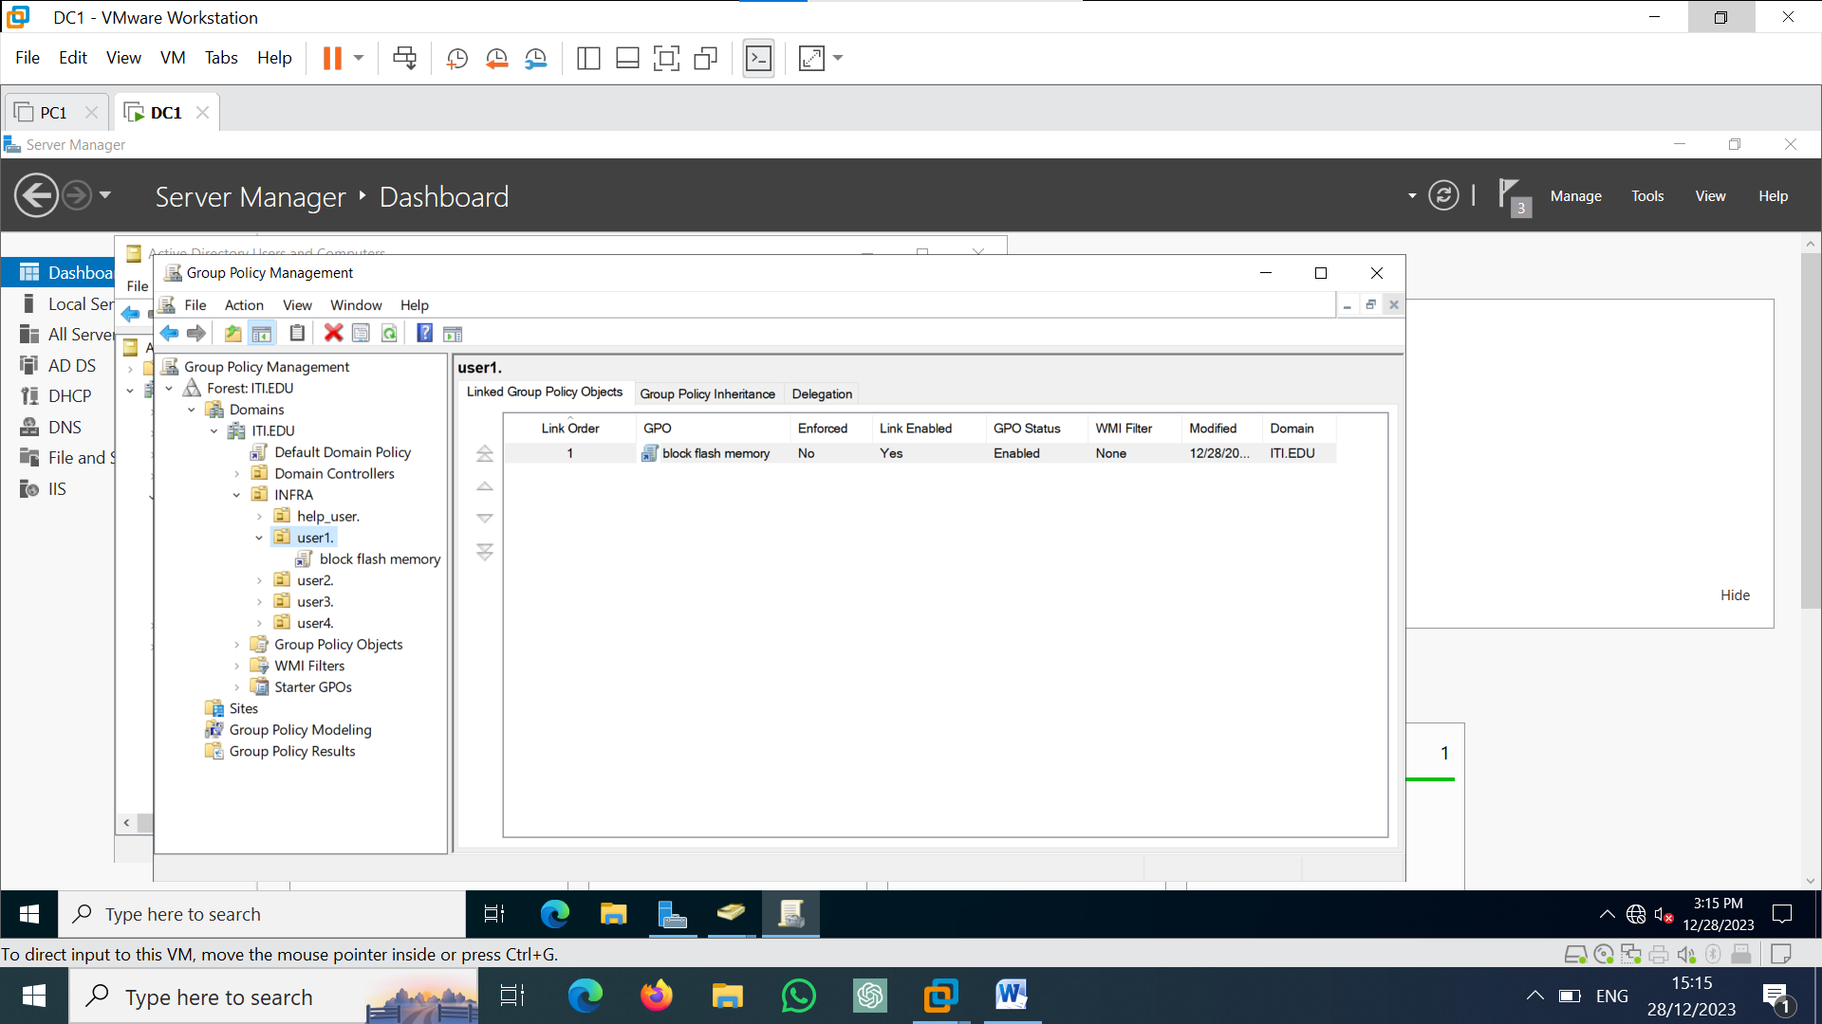

2-add policy installation for user2

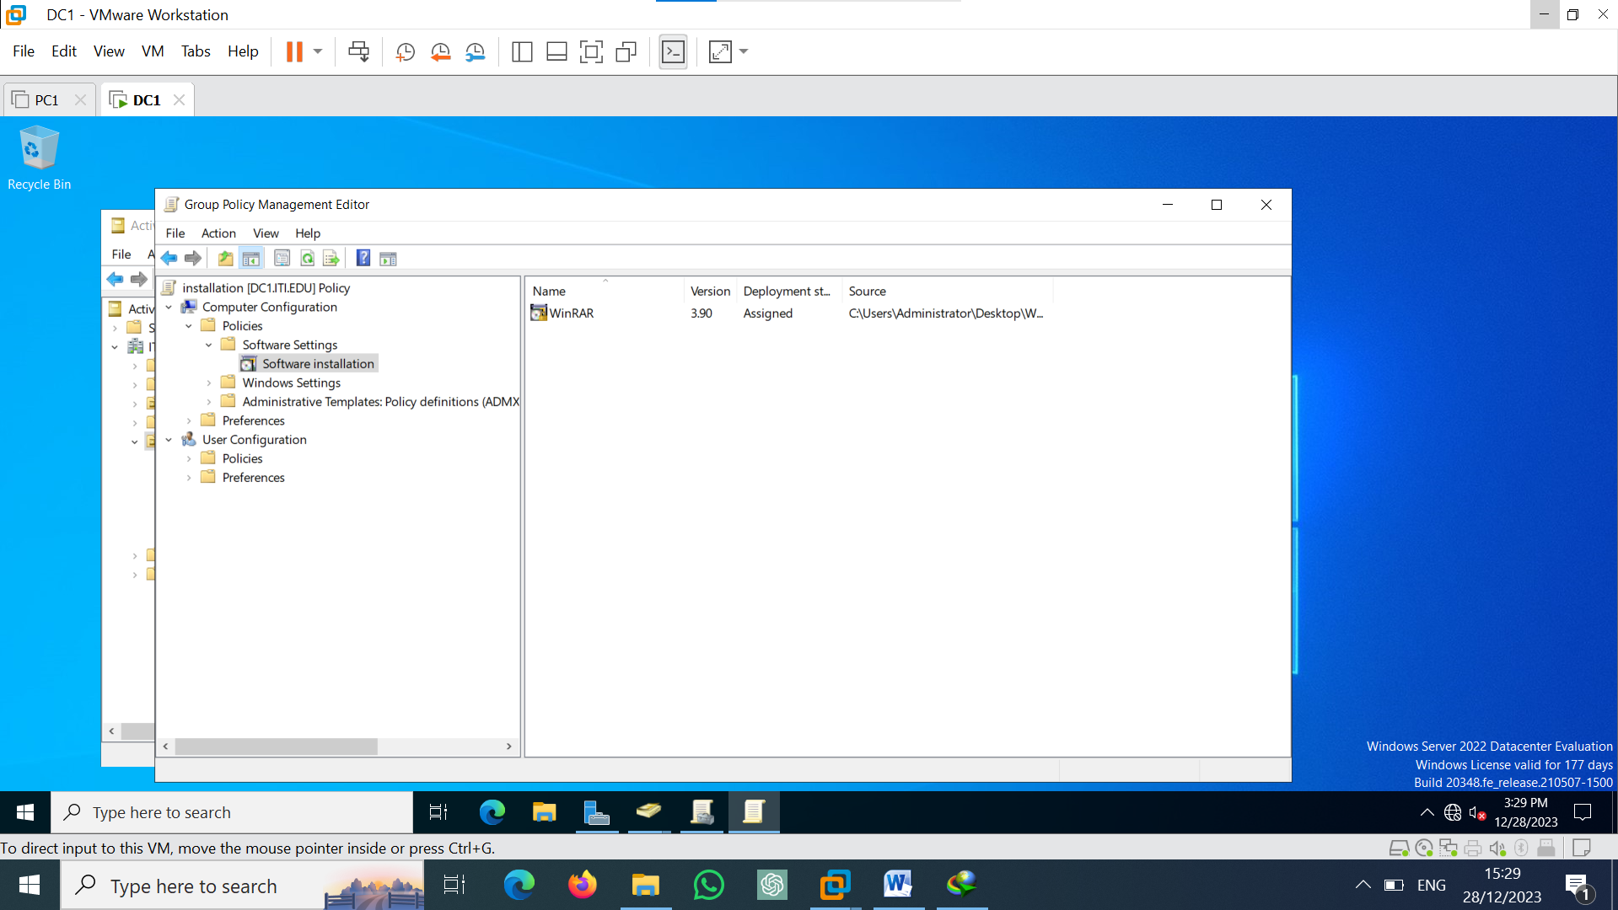

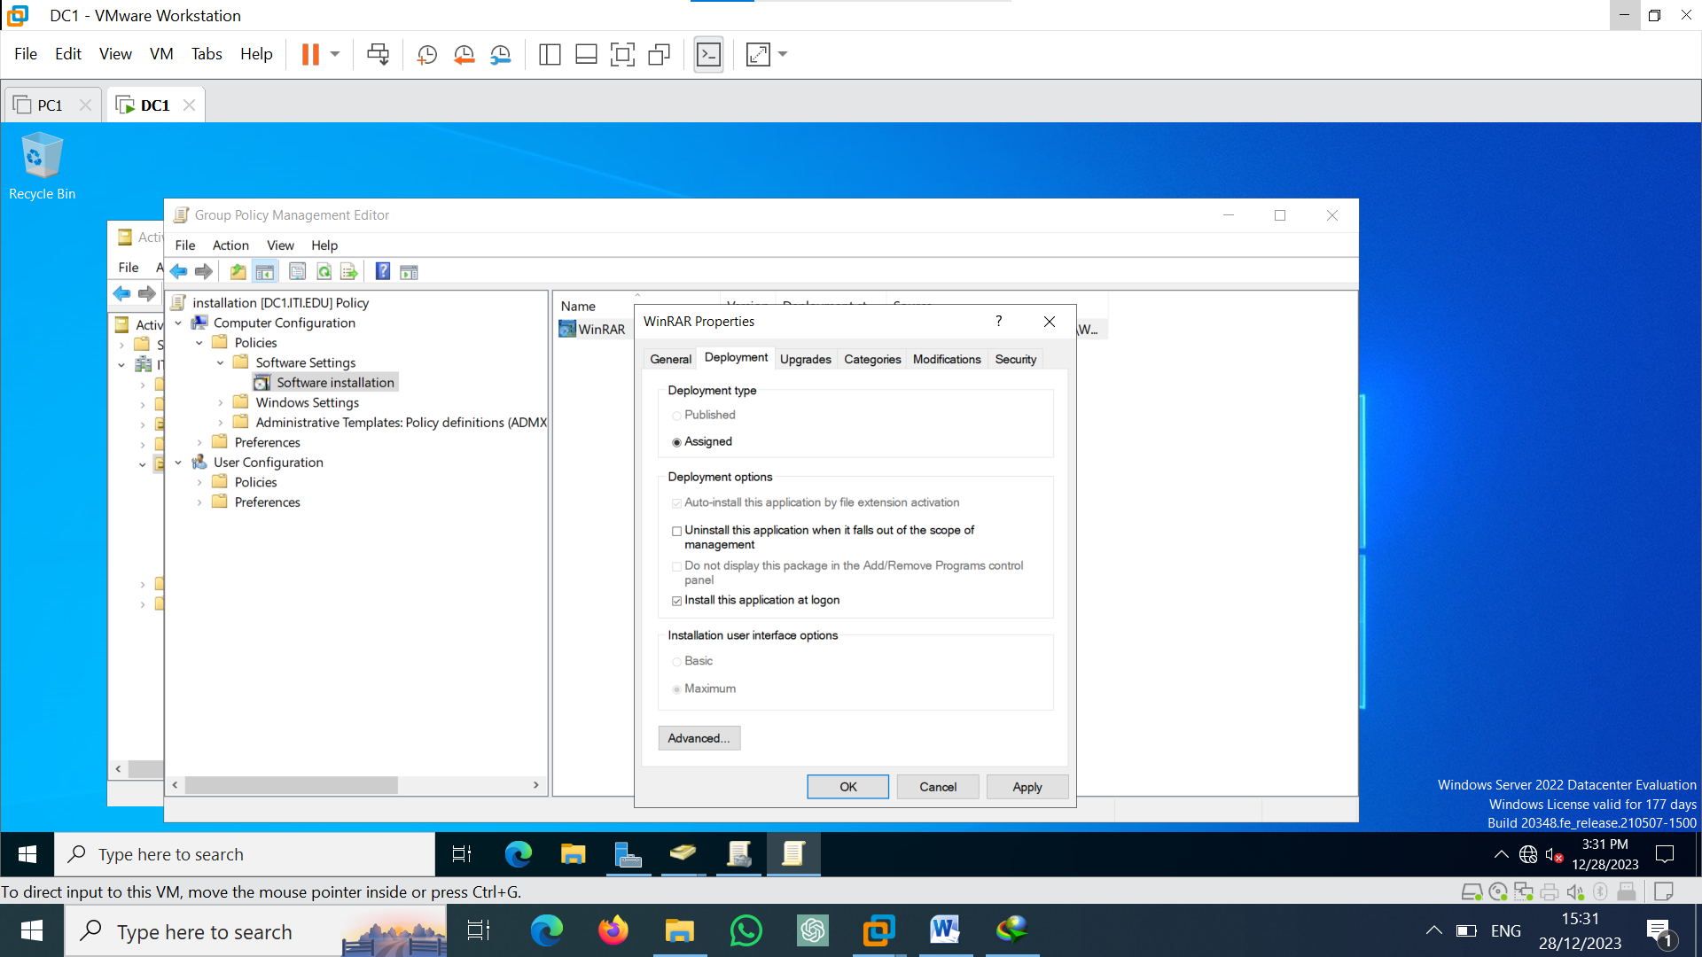

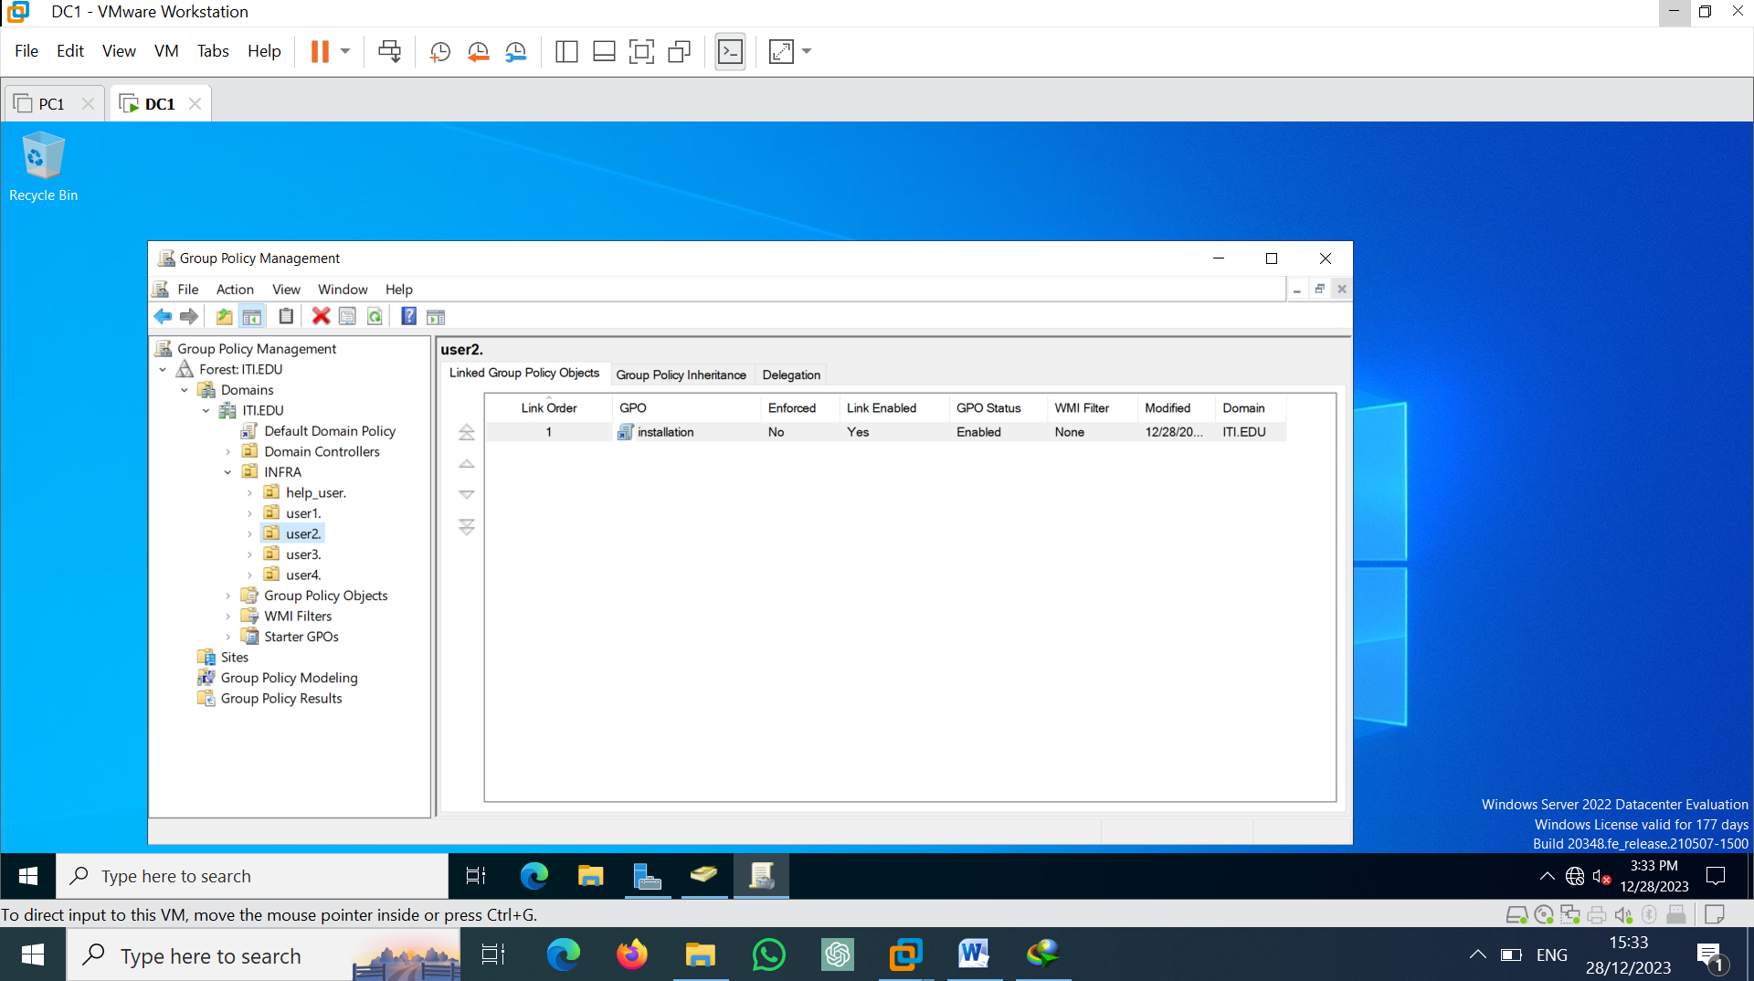

Create web site & use DNS to publish it

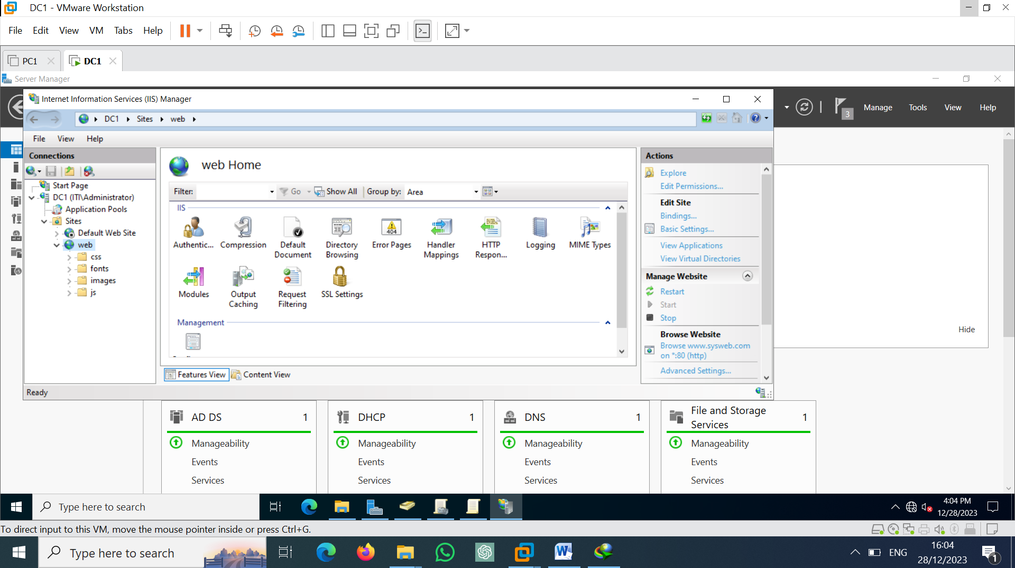

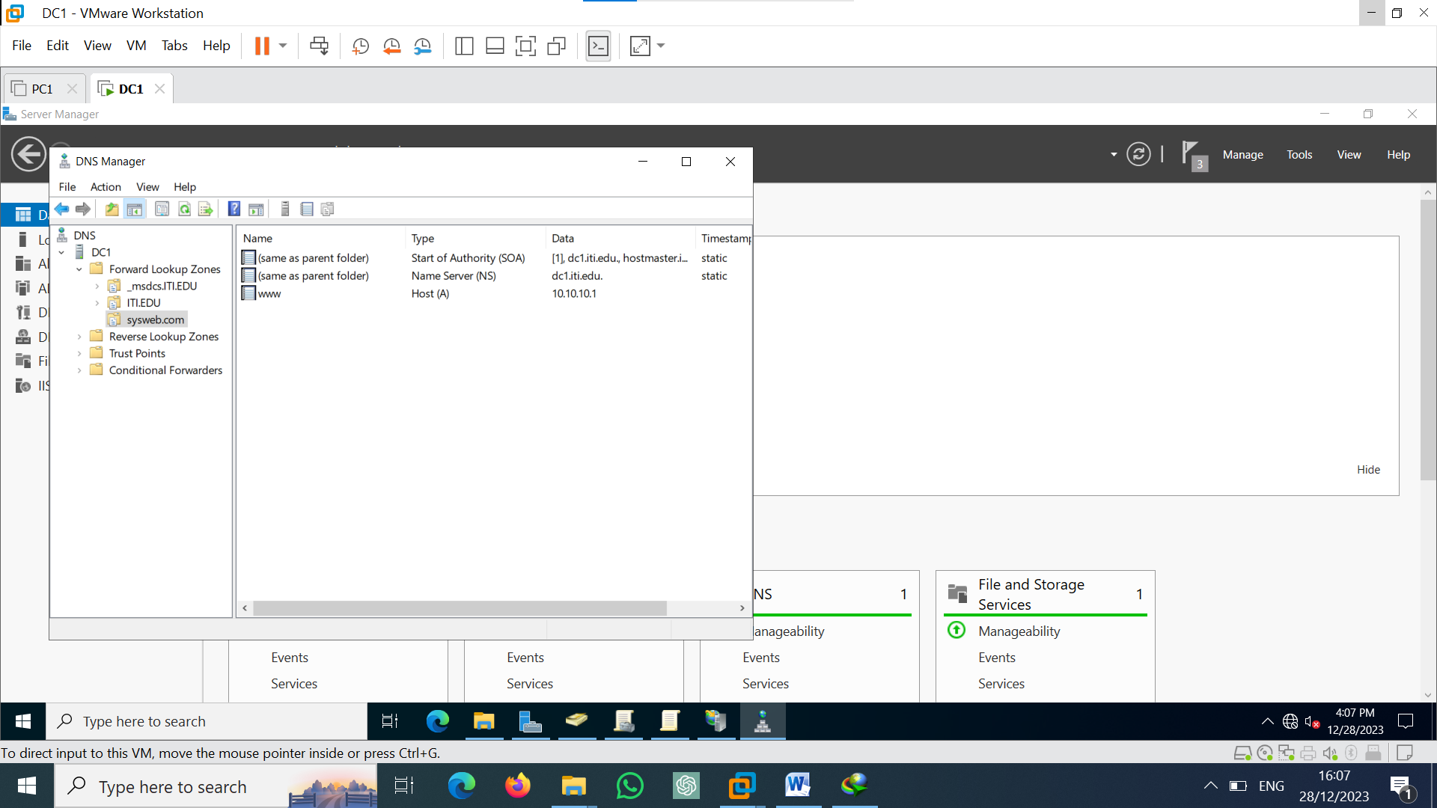

Dhcp configuration

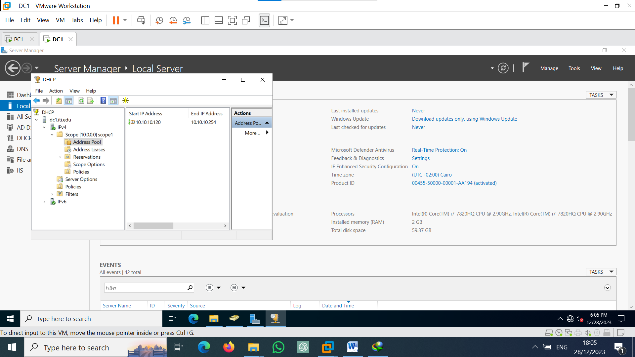

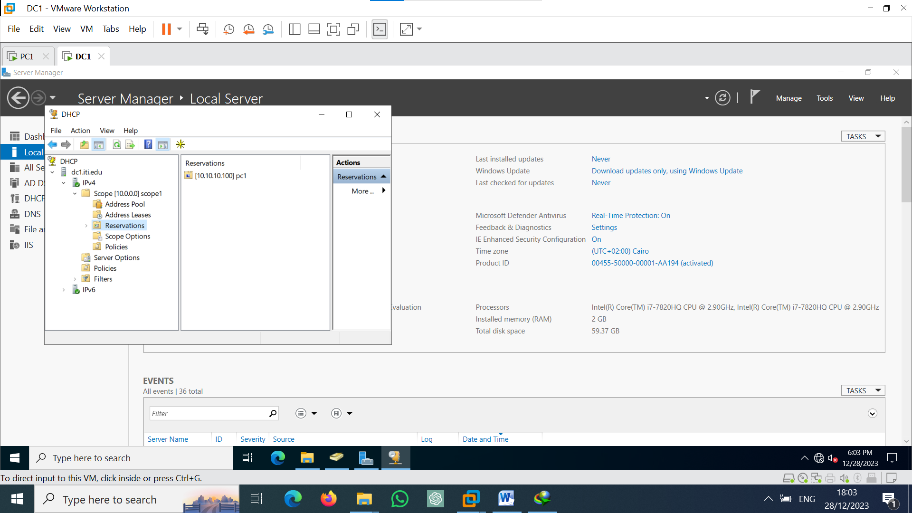

Remote desktop configuration

Set user4 member of remote desktop user & administrator user

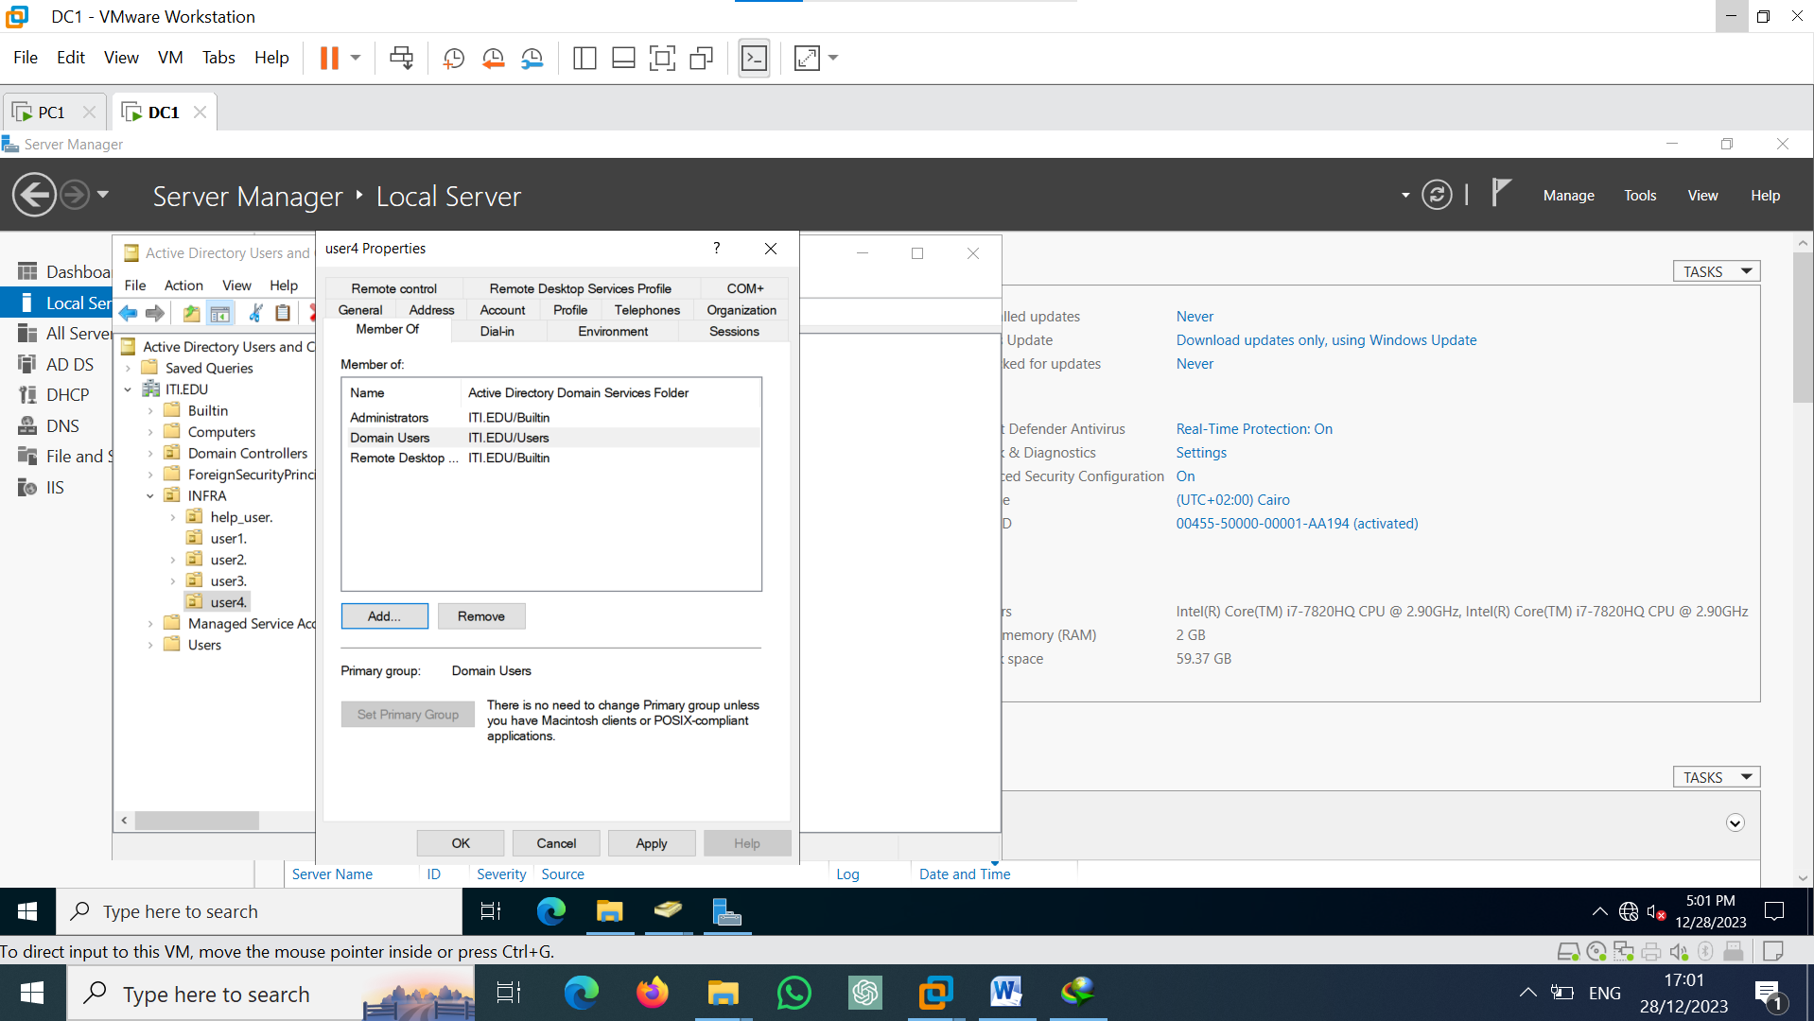

**On pc1**

Join domain

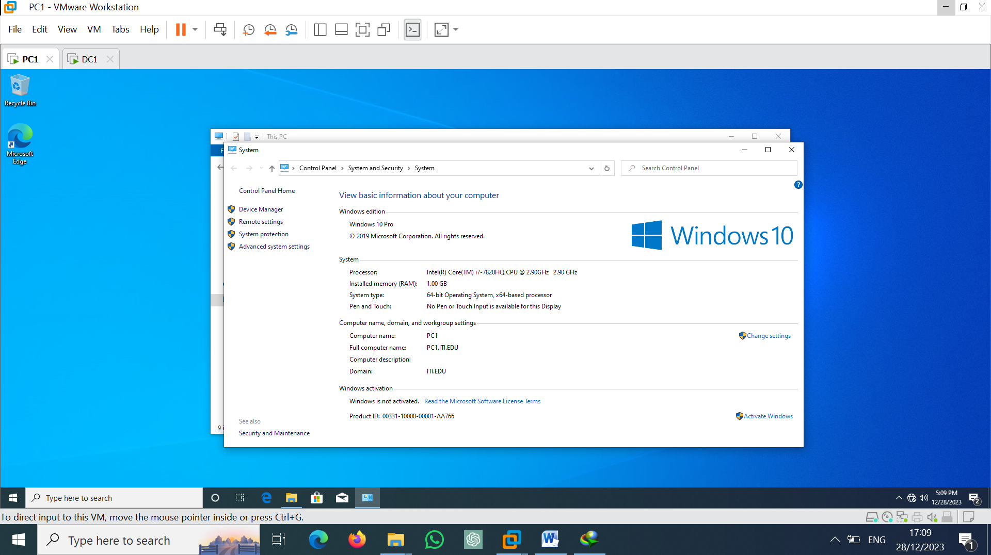

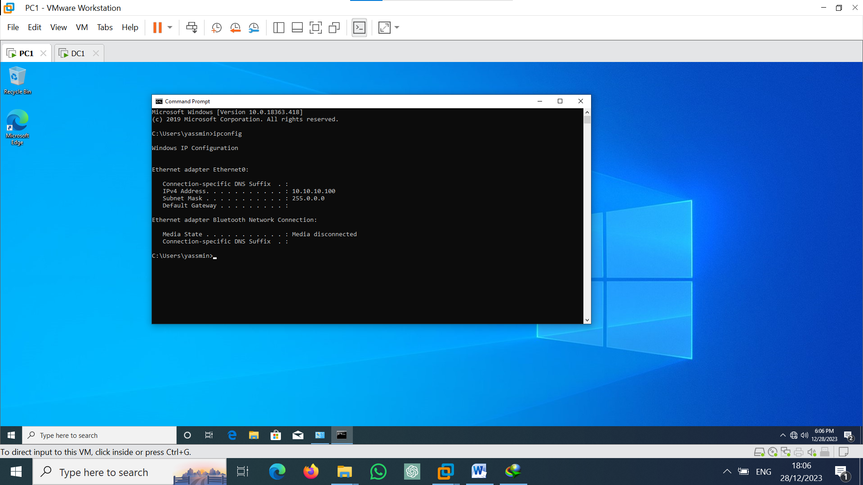

Login user1 to pc1 and try to enter flash memory

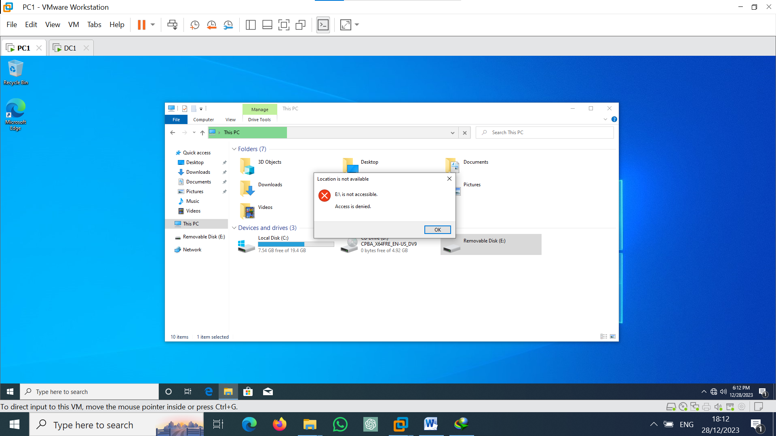

Install winrar on user 2

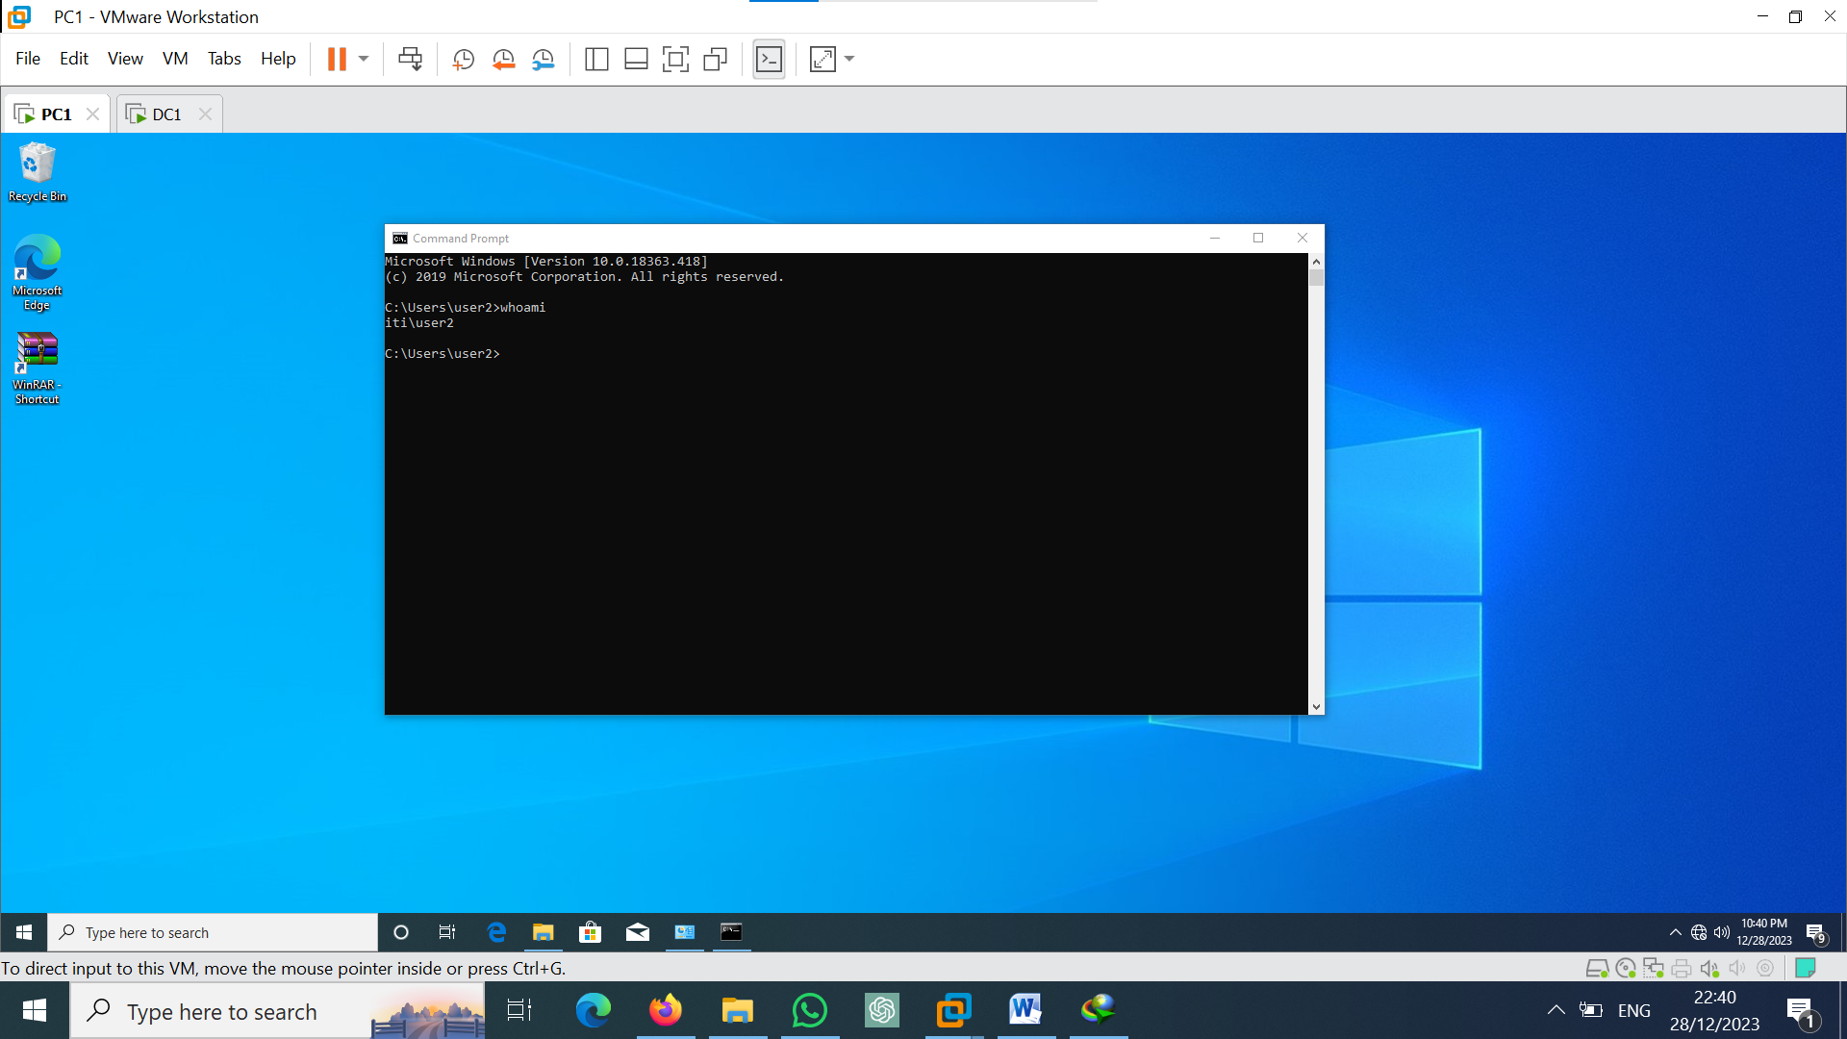

On user3

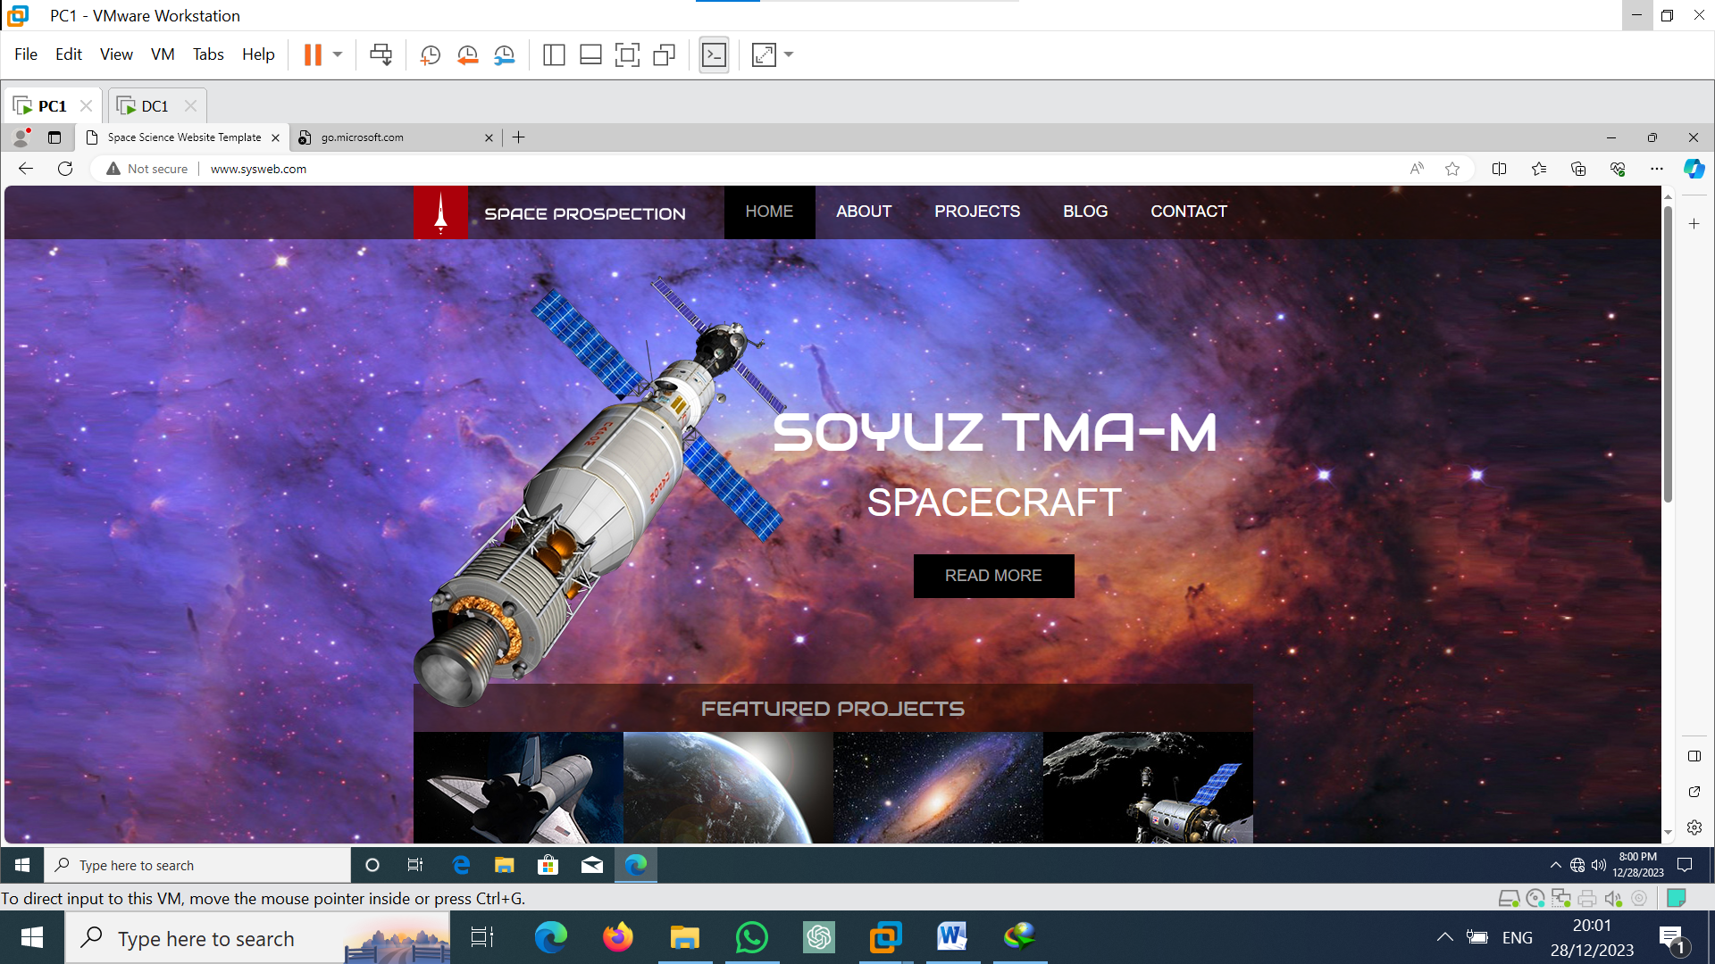

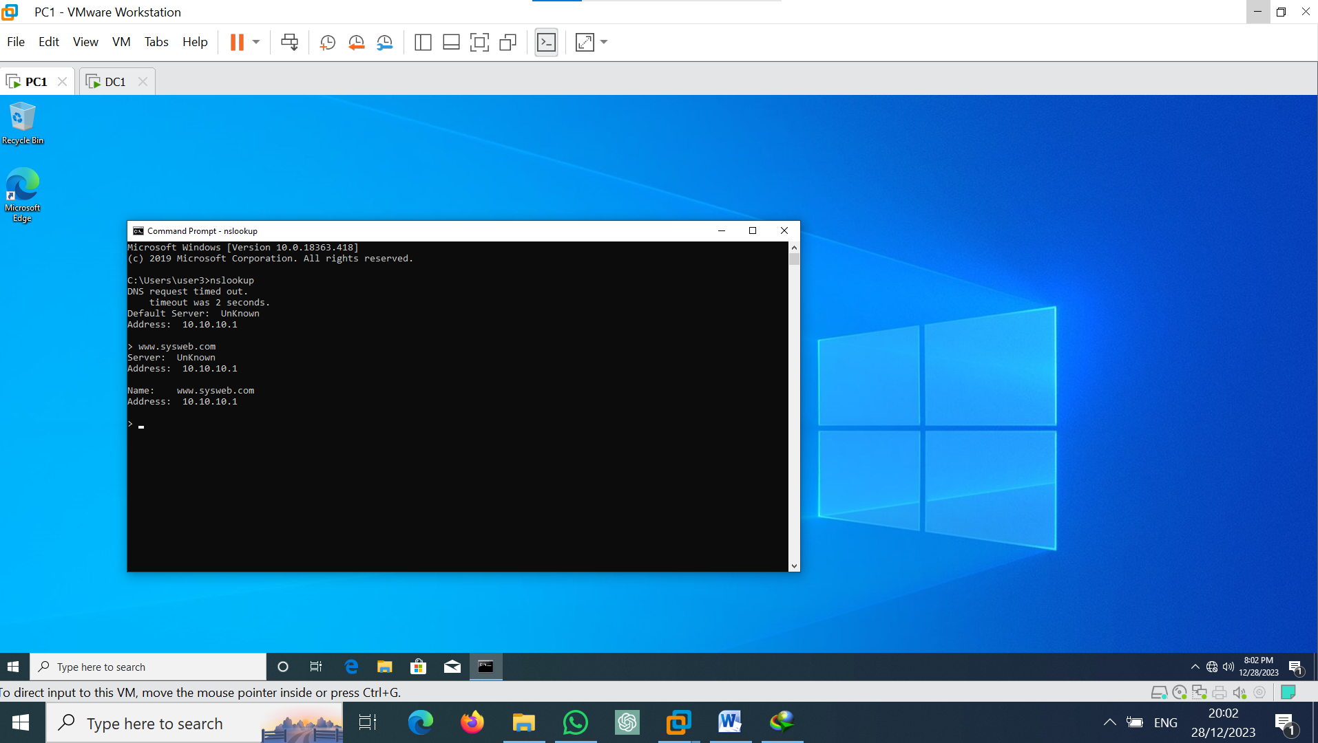

On user4

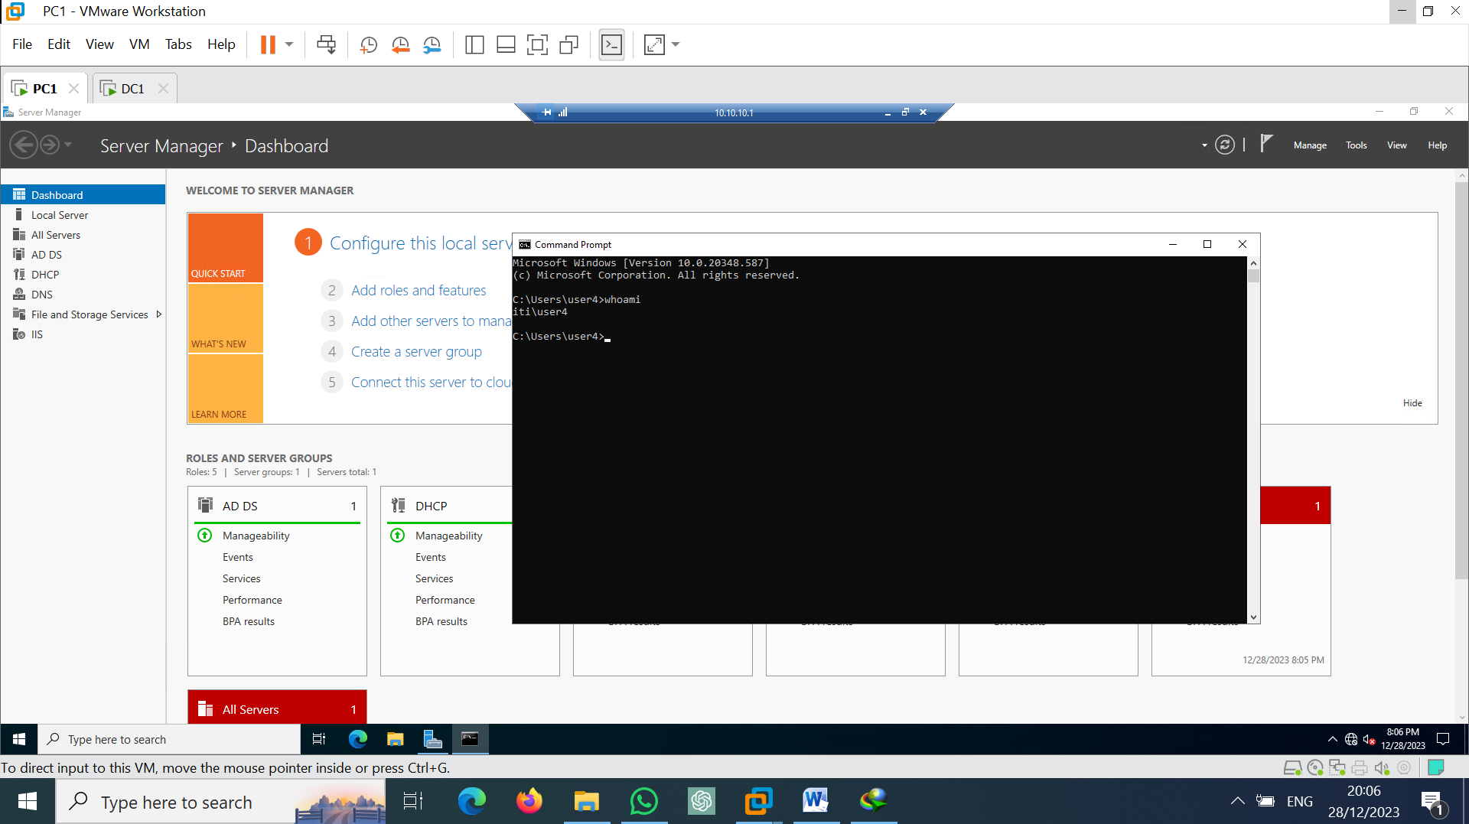

**On dc2**

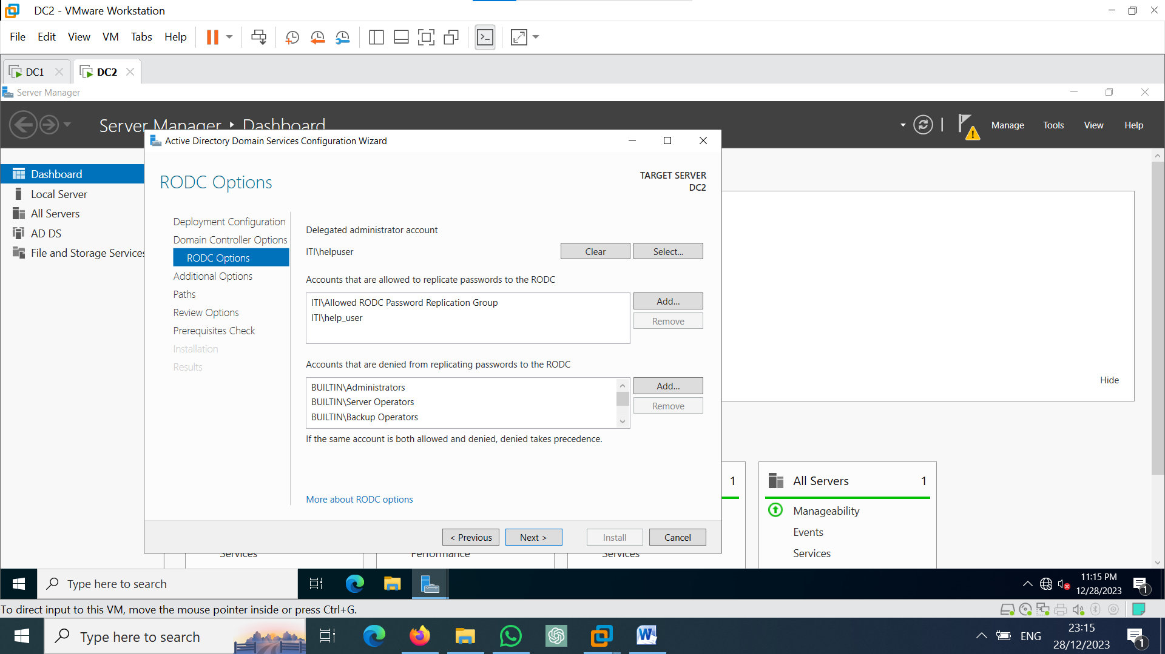

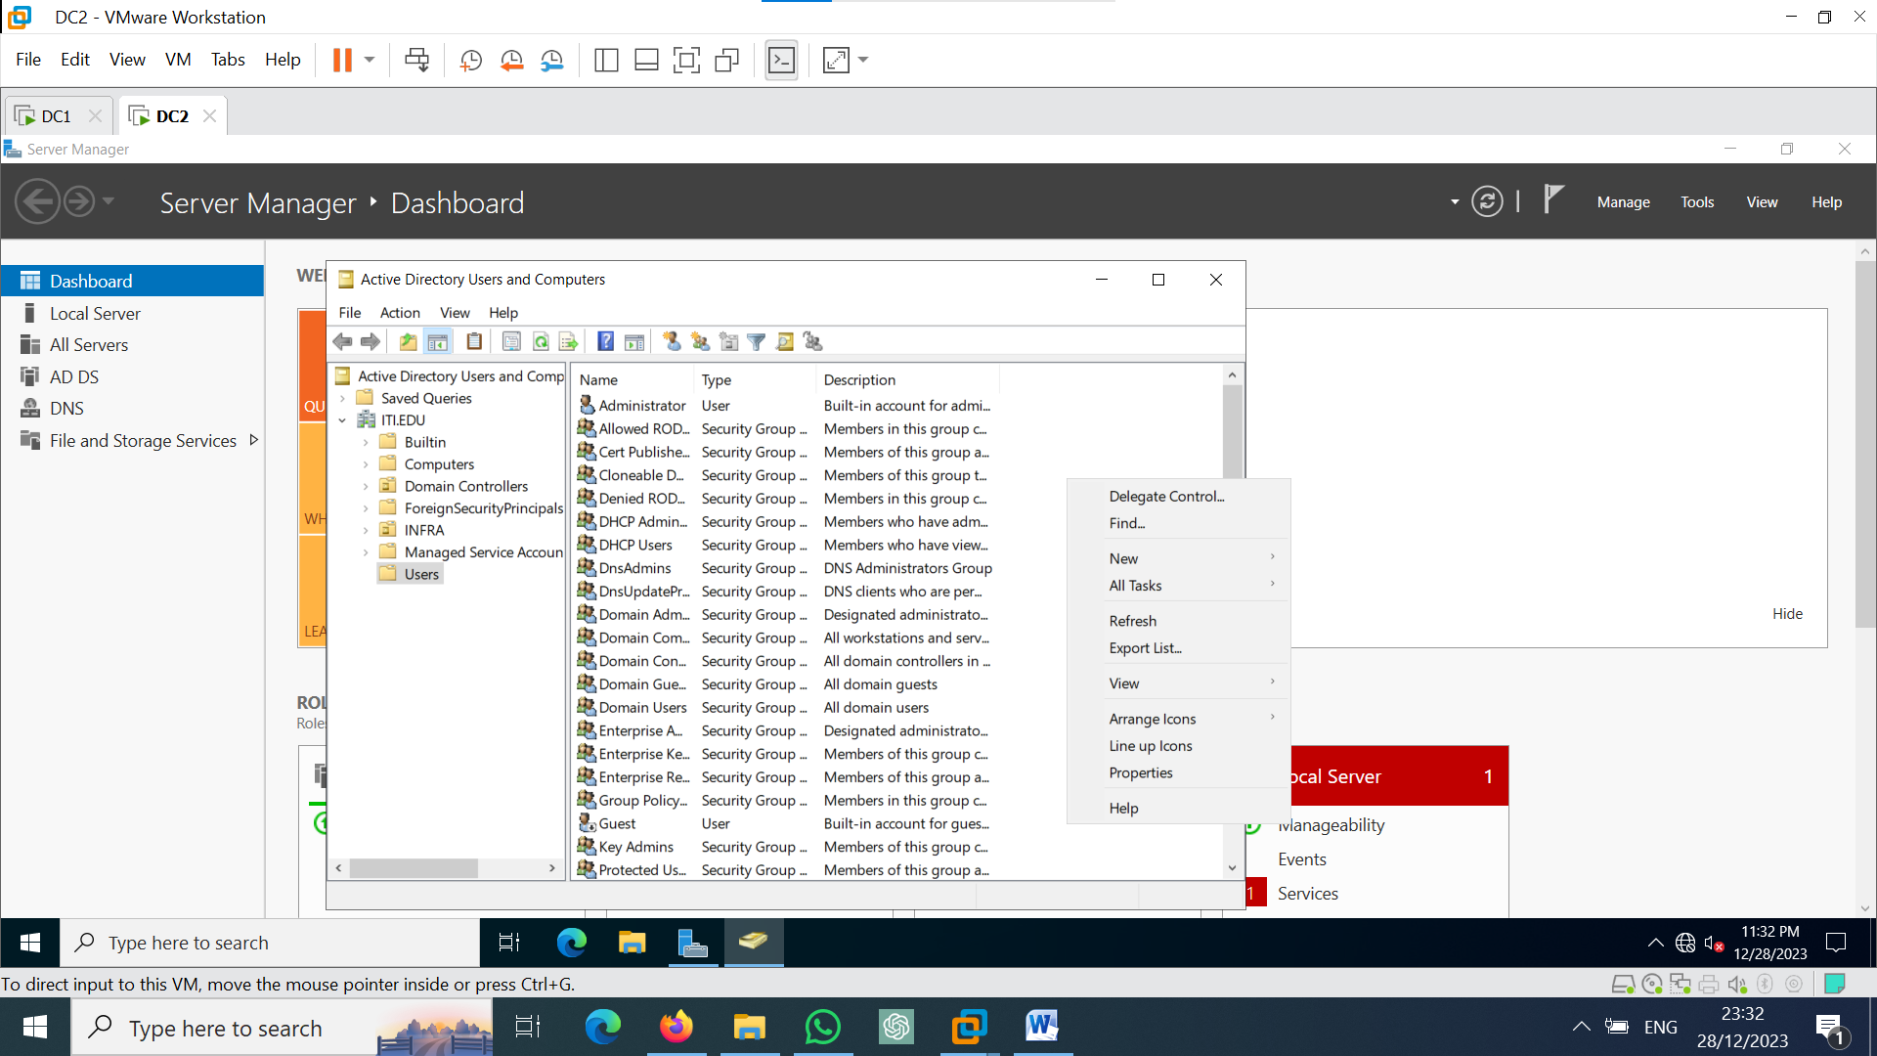

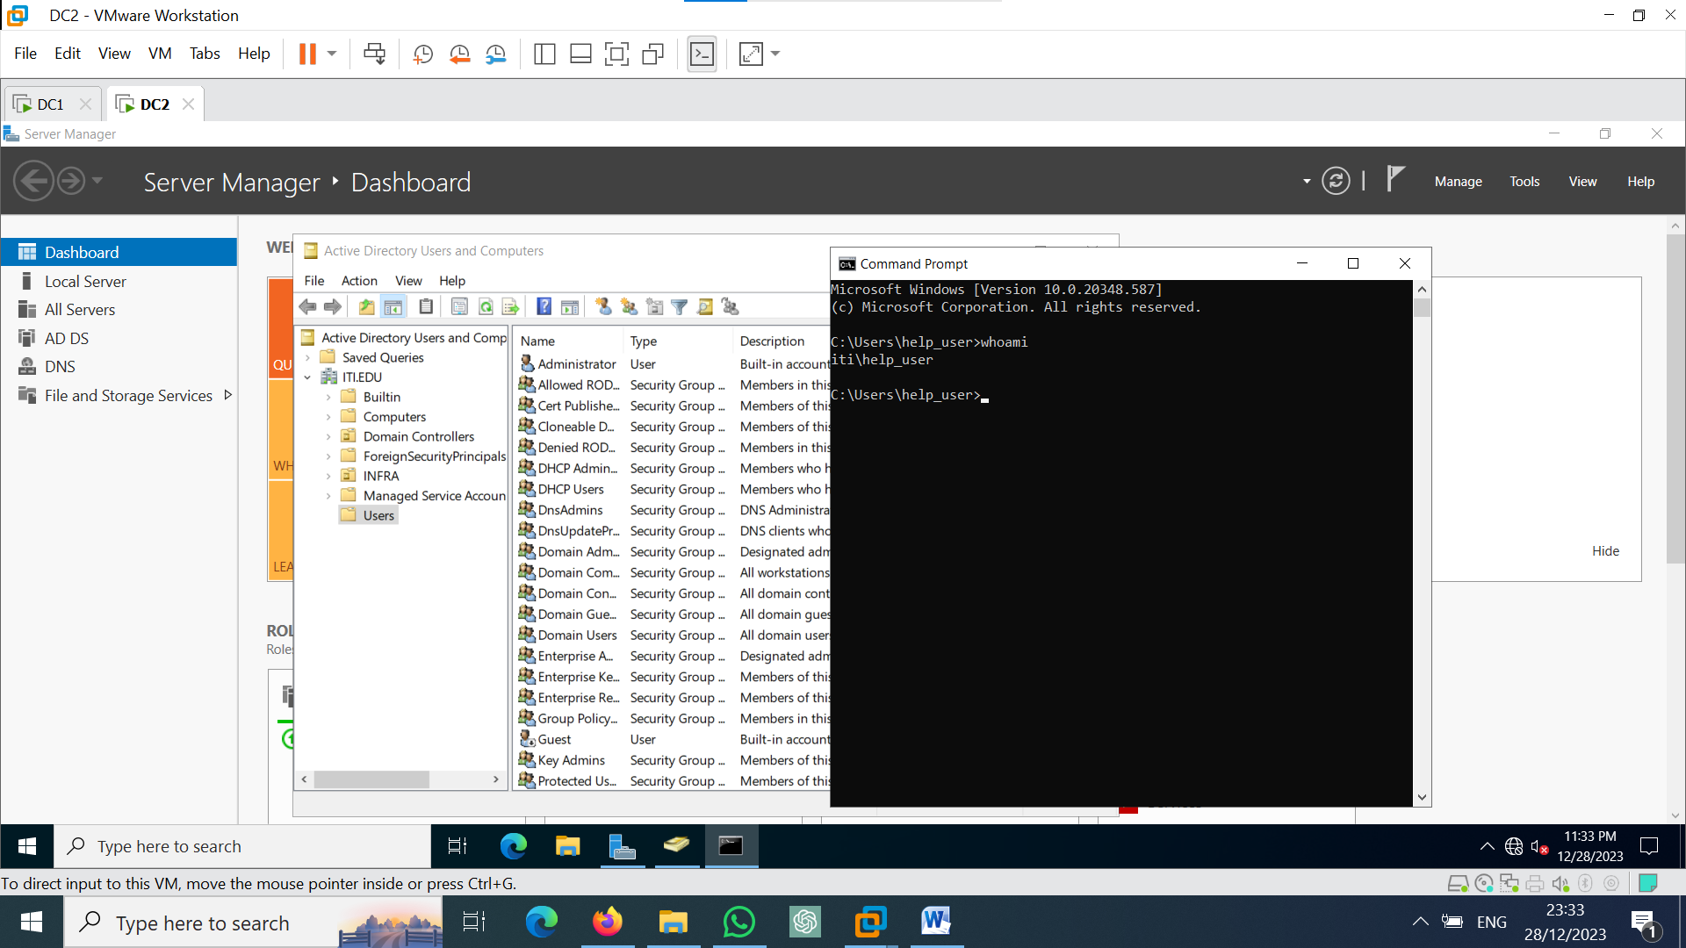

**Bulk user creation**

1-Open power shell and create ou ‘bulkuser’ and create user ‘reham’ in it

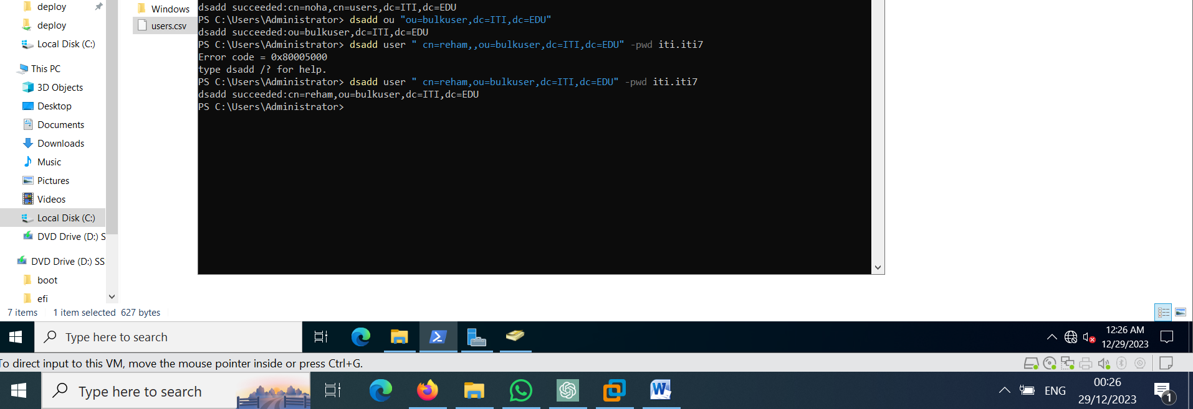

2-copy “dsadd user " cn=reham,ou=bulkuser,dc=ITI,dc=EDU" -pwd iti.iti7”

In text file and repetition it 20 times with change user nam

3-convert extension of txt file to batch file

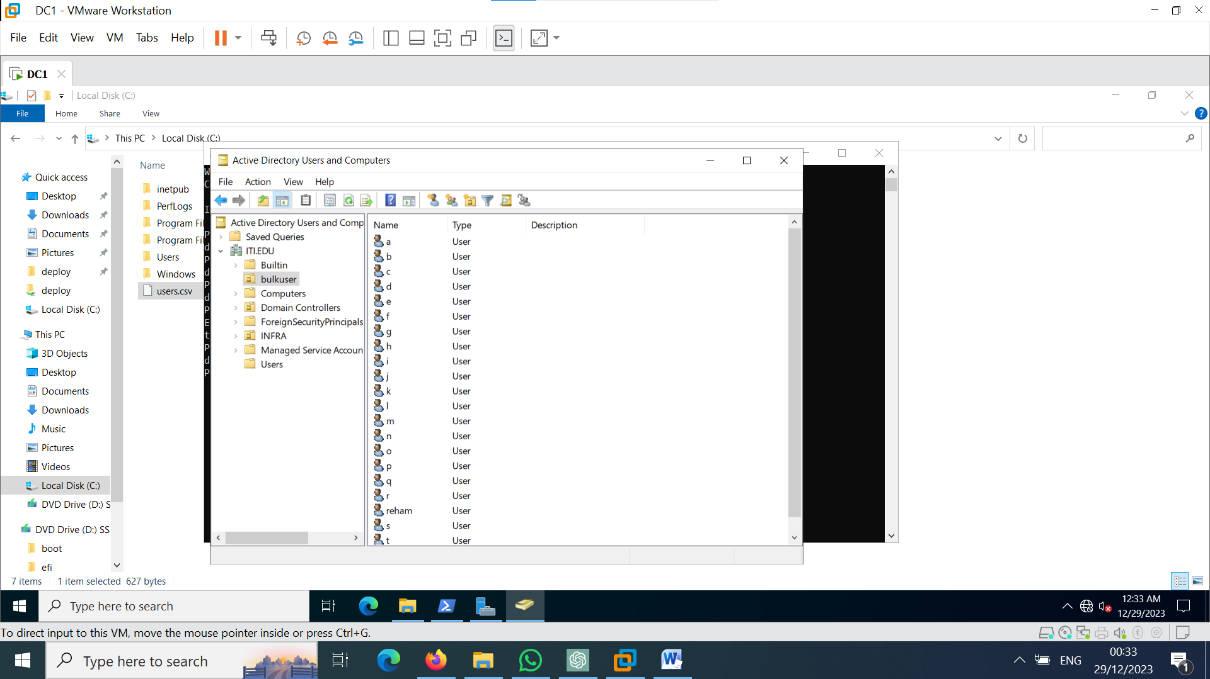

**Wdm service**

